Project Design Phase-II Technology Stack (Architecture & Stack)

Date | 20 february 2026
Team ID | LTVIP2026TMIDS72915
Project Name | Measuring the pulse of prosperity :- An index of economic freedom analysis
Maximum Marks | 4 Marks

Technical Architecture:
The Deliverable shall include the architectural diagram as below and the information as per the table1 & table 2
Example: Order processing during pandemics for offline mode
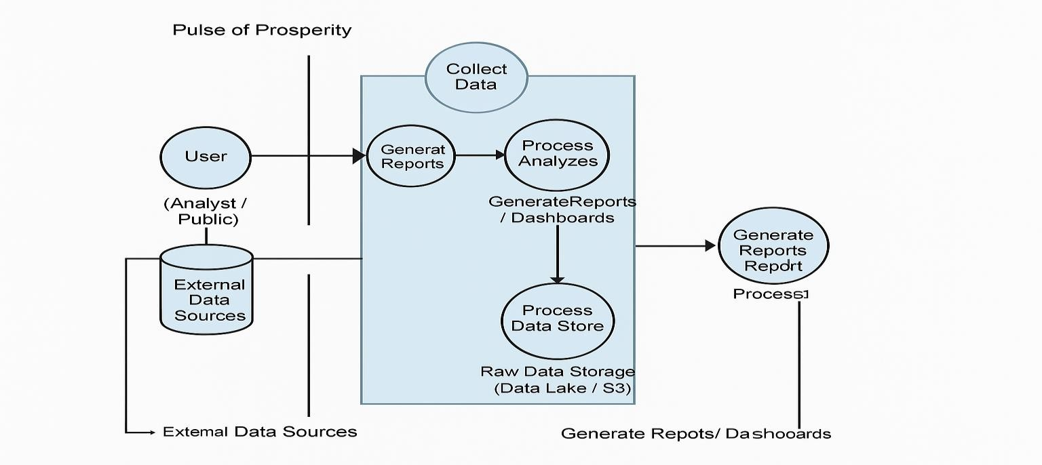

Table-1 : Components & Technologies:

S.No | Component | Description | Technology
1. | User Interface | Web and mobile dashboards for data viewing | HTML, CSS, JavaScript / Angular Js / React Js etc.
2. | Application Logic-1 | Handling filters, comparisons, and data analysis | Java / Python
3. | Database | Stores economic data and user info | MySQL, NoSQL, etc.
4. | Cloud Database | Cloud – based database for scalability | IBM DB2, IBM Cloudant etc.
5. | File Storage | Stores downloadable files like reports | IBM Block Storage or Other Storage Service or Local Filesystem
6. | External API-1 | Gets economic indicators or live data | IBM Weather API, etc.
7. | External API-2 | Country metadata (names, flags etc.,) | Aadhar API, etc.
8. | Machine Learning Model | Predicts economic trends | Object Recognition Model, etc.
9. | Infrastructure (Server / Cloud) | Cloud hosting and deployment | Local, Cloud Foundry, Kubernetes, etc.

Table-2: Application Characteristics:

S.No | Characteristics | Description | Technology
1. | Open-Source Frameworks | Use of open – source tools for front- end, back- end, and visualization | Technology of Opensource framework
2. | Security Implementations | Secure login, encrypted data, API access control, use of firewalls | e.g. SHA-256, Encryptions, IAM Controls, OWASP etc.
3. | Scalable Architecture | Supports scaling using micro services and tiered architecture | Technology used
4. | Availability | Ensures system uptime with distributed servers and load balancers | Technology used

S.No | Characteristics | Description | Technology
5. | Performance | Optimized for fast data load and response using cache and CDNs | Technology used

